1. In Assignment 3 of previous session, print the details of Managers with the help ofdelegate

EmployeeDelegate. (UniCast Delegate)

1. Create a MultiCast Delegate by adding address of another method to the above delegate to list the details of MarketingExecutive.

using System;

using System.Collections.Generic;

using System.Linq;

using System.Text;

using System.Threading.Tasks;

namespace Delegates

{//Multicaste Delegate//

public delegate void EmployeeDelegate();

public class MultiCastDelegate

{

static void Main(string[] args)

{

EmployeeDelegate empdel1 = new EmployeeDelegate(KillometerTravel);

EmployeeDelegate empdel2 = new EmployeeDelegate(Tourallowance);

EmployeeDelegate empdel3 = new EmployeeDelegate(Telephoneallowance);

EmployeeDelegate empdel4 = new EmployeeDelegate(details);

EmployeeDelegate empdel5 = empdel1 + empdel2 + empdel3 + empdel4;

empdel5();

}

public static void KillometerTravel()

{

int kt = 2;

Console.WriteLine("Kilometertravel: {0}", kt);

}

public static void Tourallowance()

{

int kt = 2;

int ta = (int)kt * 5;

Console.WriteLine("Tour Allowance:{0}", ta);

}

public static void Telephoneallowance()

{

int tpa = 1000;

Console.WriteLine("Telephone Allowance:{0}", tpa);

}

public static void details()

{

int ID = 1;

string name = "Rasika";

int salary = 20000;

Console.WriteLine("MarketingExecutive ID:{0}", ID);

Console.WriteLine("MarketingExecutive Name:{0}", name);

Console.WriteLine("MarketingExecutive salary:{0}", salary);

}

}

}

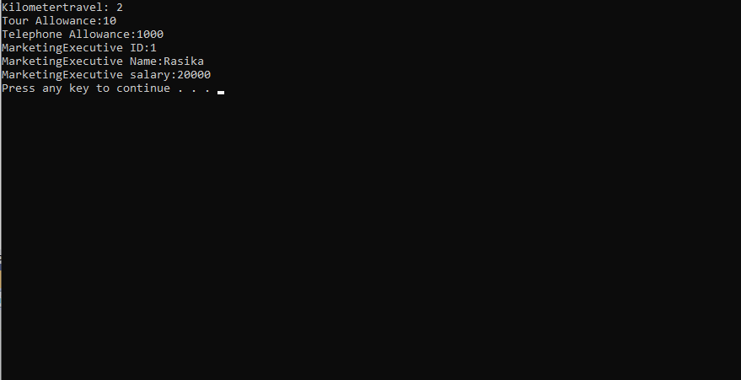

3)Write a console Application for banking domain, having Accountclass with data members asaccountnumber,customername,balance.ItshouldhaveWithdrawand Deposit methods for performing banking transaction. It should also define UnderBalance, BalanceZeroevents. These events would be raised when balance of account is less than certain amount and equal to zerorespectively.

1)Writeseparate ICICIBankclass with EventHandlersfor UnderBalanceand

BalanceZeroEvents.

* 1. Show message "Transaction cannot be continued as balance is insufficient/zero in Account".

1. Writeseparate HDFCBankclasswith EventHandlersforUnderBalanceand

BalanceZeroEvents.

* 1. EventHandler should allow account holder to withdraw money till balance goes to Rs - 1000;below this show message "Transaction cannot be continued below specified limit of Rs.-1000".

using System;

using System.Collections.Generic;

using System.Linq;

using System.Text;

using System.Threading.Tasks;

namespace _6th_3rd

{

internal class Program

{

static void Main(string[] args)

public double AccountNumber = 7857422676;

public string Name = "swati More";

public double bankbalance = 18700;

public void data()

{

// BankAccount Accounts = new BankAccount();

// Console.WriteLine("enter account number");

// Accounts.AccountNumber = Convert.ToInt64(Console.ReadLine());

// Console.WriteLine("enter your name");

// Accounts.Name = Console.ReadLine();

// Console.WriteLine("enter"

// Accounts.bankbalance = Convert.ToInt64(Console.ReadLine());

Console.WriteLine("Accountnumber={0}\nAccountHolder={1}\nBankbalance={2}", AccountNumber, Name, bankbalance);

}

public void deposit(double money)

{

if (money > 0)

{

bankbalance = bankbalance + money;

Console.WriteLine("Bank Balance=" + bankbalance);

}

else

{

Console.WriteLine("enter correct value of amount");

}

Console.WriteLine("Bank Balance=" + bankbalance);

}

public void withdraw(double amount)

{

if (amount < bankbalance)

{

bankbalance -= amount;

}

else if (amount > bankbalance)

{

Console.WriteLine("Insufficient Balance");

}

else

{

Console.WriteLine("select correct choice");

}

Console.WriteLine("Bank Balance=" + bankbalance);

}

public void balance()

{

Console.WriteLine("bank balance=" + bankbalance);

}

}

}

4.

using System;

using System.Collections.Generic;

using System.Linq;

using System.Text;

using System.Threading.Tasks;

namespace Bank

{

class BankAccount

{

public double AccountNumber = 7389222676;

public string Name = "Swati More";

public double bankbalance = 13500;

public void data()

{

// BankAccount Accounts = new BankAccount();

// Console.WriteLine("enter account number");

// Accounts.AccountNumber = Convert.ToInt64(Console.ReadLine());

// Console.WriteLine("enter your name");

// Accounts.Name = Console.ReadLine();

// Console.WriteLine("enter"

// Accounts.bankbalance = Convert.ToInt64(Console.ReadLine());

Console.WriteLine("Accountnumber={0}\nAccountHolder={1}\nBankbalance={2}", AccountNumber, Name, bankbalance);

}

public void deposit(double money)

{

if (money > 0)

{

bankbalance = bankbalance + money;

Console.WriteLine("Bank Balance=" + bankbalance);

}

else

{

Console.WriteLine("enter correct value of amount");

}

Console.WriteLine("Bank Balance=" + bankbalance);

}

public void withdraw(double amount)

{

if (amount < bankbalance)

{

bankbalance -= amount;

}

else if (amount > bankbalance)

{

Console.WriteLine("Insufficient Balance");

}

else

{

Console.WriteLine("select correct choice");

}

Console.WriteLine("Bank Balance=" + bankbalance);

}

public void balance()

{

Console.WriteLine("bank balance=" + bankbalance);

}

}

class ICICIBankAccount : BankAccount

{

public void withdraw(double amount)

{

if (amount < bankbalance)

{

bankbalance -= amount;

}

else if (amount > bankbalance)

{

Console.WriteLine("Transaction cannot be continued as balance is insufficient in Account");

}

else

{

Console.WriteLine("select correct choice");

}

Console.WriteLine("Bank Balance=" + bankbalance);

}

public void balance()

{

if (bankbalance == 0)

{

Console.WriteLine("Transaction cannot be continued as balance is zero in Account");

}

Console.WriteLine("bank balance=" + bankbalance);

}

}

class HDFCBankAccount : BankAccount

{

public void withdraw(double amount)

{

if (amount < bankbalance & bankbalance > 1000)

{

bankbalance -= amount;

}

else if (amount < bankbalance & bankbalance < 1000)

{

Console.WriteLine("Transaction cannot be continued below specified limit of Rs.- 1000");

}

else

{

Console.WriteLine("select correct choice");

}

Console.WriteLine("Bank Balance=" + bankbalance);

}

public void balance()

{

if (bankbalance == 0)

{

Console.WriteLine("Transaction cannot be continued as balance is zero in Account");

}

Console.WriteLine("bank balance=" + bankbalance);

}

}

class transactions

{

public static void Main()

{

try

{

again:

Console.WriteLine("enter which banktransaction you want to do\n 1.Bank\n2.ICICI\n3.HDFC\n4.Exit ");

string ba = Console.ReadLine();

if (ba.ToUpper() == "BANK")

{

transactions.BankTransactions();

}

else if (ba.ToUpper() == "ICICI")

{

transactions.ICICIBankTransactions();

}

else if (ba.ToUpper() == "HDFC")

{

transactions.HDFCBankTransactions();

}

else if (ba.ToUpper() == "EXIT")

{

Console.WriteLine("thank you");

}

else

{

Console.WriteLine("select correct choice");

goto again;

}

}

catch (Exception ex)

{

Console.WriteLine(ex.GetType().Name);

}

}

public static void BankTransactions()

{

BankAccount b = new BankAccount();

b.data();

tran:

Console.WriteLine("enter youer choice\n1.depoist\n2.withdraw\n3.balance\n4.exit\nselect respective number for transactions");

int choice = Convert.ToInt32(Console.ReadLine());

{

if (choice == 1)

{

Console.WriteLine("enter the amount");

int amnt = Convert.ToInt32(Console.ReadLine());

b.deposit(amnt);

goto tran;

}

else if (choice == 2)

{

Console.WriteLine("enter the amount");

int amnt = Convert.ToInt32(Console.ReadLine());

b.withdraw(amnt);

goto tran;

}

else if (choice == 3)

{

b.balance();

goto tran;

}

else if (choice == 4)

{

Console.WriteLine("thank you");

}

else

{

Console.WriteLine("select correct choice");

goto tran;

}

b.balance();

if (b.bankbalance < 1000)

{

Console.WriteLine("account is underbalance" + b.bankbalance);

}

else if (b.bankbalance == 0)

{

Console.WriteLine("bank balance is zero");

}

}

}

public static void ICICIBankTransactions()

{

ICICIBankAccount b = new ICICIBankAccount();

b.data();

tran:

Console.WriteLine("enter youer choice\n1.depoist\n2.withdraw\n3.balance\n4.exit\nselect respective number for transactions");

int choice = Convert.ToInt32(Console.ReadLine());

{

if (choice == 1)

{

Console.WriteLine("enter the amount");

int amnt = Convert.ToInt32(Console.ReadLine());

b.deposit(amnt);

goto tran;

}

else if (choice == 2)

{

Console.WriteLine("enter the amount");

int amnt = Convert.ToInt32(Console.ReadLine());

b.withdraw(amnt);

goto tran;

}

else if (choice == 3)

{

b.balance();

goto tran;

}

else if (choice == 4)

{

Console.WriteLine("thank you");

}

else

{

Console.WriteLine("select correct choice");

goto tran;

}

b.balance();

if (b.bankbalance < 1000)

{

Console.WriteLine("account is underbalance" + b.bankbalance);

}

else if (b.bankbalance == 0)

{

Console.WriteLine("bank balance is zero");

}

}

}

public static void HDFCBankTransactions()

{

HDFCBankAccount b = new HDFCBankAccount();

b.data();

tran:

Console.WriteLine("enter youer choice\n1.depoist\n2.withdraw\n3.balance\n4.exit\nselect respective number for transactions");

int choice = Convert.ToInt32(Console.ReadLine());

{

if (choice == 1)

{

Console.WriteLine("enter the amount");

int amnt = Convert.ToInt32(Console.ReadLine());

b.deposit(amnt);

goto tran;

}

else if (choice == 2)

{

Console.WriteLine("enter the amount");

int amnt = Convert.ToInt32(Console.ReadLine());

b.withdraw(amnt);

goto tran;

}

else if (choice == 3)

{

b.balance();

goto tran;

}

else if (choice == 4)

{

Console.WriteLine("thank you");

}

else

{

Console.WriteLine("select correct choice");

goto tran;

}

b.balance();

if (b.bankbalance < 1000)

{

Console.WriteLine("account is underbalance" + b.bankbalance);

}

else if (b.bankbalance == 0)

{

Console.WriteLine("bank balance is zero");

}

}

}

}

}

